Exploratory Data Analysis (EDA) Report: Indian Climate 2025

Exploratory data analysis (EDA) is crucial for understanding your climate data, identifying weather patterns, and generating insights that can inform environmental policy or health advisories. In this project, we implement critical steps for performing EDA on the Indianclimate.csv dataset sourced from Kaggle. This iterative procedure involves summarizing, visualizing, and exploring information to find patterns, anomalies, and relationships between weather variables and air quality.

Procedure Exploratory Data Analysis

1.Understand the Problem and the Data
2.Import and Inspect the Data
3.Handling Missing Values
4.Explore Data Characteristics
5.Perform Data Transformation
6.Visualize Data Relationships
7.Handling Outliers
8. Communicate Findings and Insights

Dataset: Indianclimate.csv from Kaggle
Project Structure:

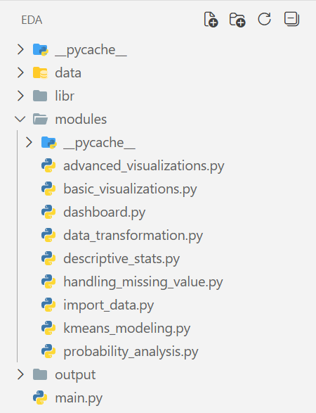

1. Understand the Problem and the Data
The objective of this project is to analyze climate variations across major Indian cities and identify relationships between temperature, humidity, rainfall, and Air Quality Index (AQI).
Variables in our Dataset:
- Numerical: Temperature (Max, Min, Avg), Humidity, Rainfall, Wind Speed, AQI, Pressure, Cloud Cover.
- Categorical: City, State, AQI_Category.
- Temporal: Date



2.Import and Inspect the Data

File Name: import_data.py
The dataset is loaded into a Pandas DataFrame using the read_csv() function. This allows us to access, manipulate, and analyze the climate data efficiently.
The function load_data() performs the following tasks:
- Displays the first five rows of the dataset using head() to give a quick overview of the climate records for Indian cities.
- Uses info() to inspect the structure of the dataset, including:
  - Column names
  - Data types of each variable
  - Count of non-null values
  - Total number of entries
This step helps in identifying missing values, incorrect data formats, and the overall size of the dataset, which is essential before proceeding to data cleaning and transformation.

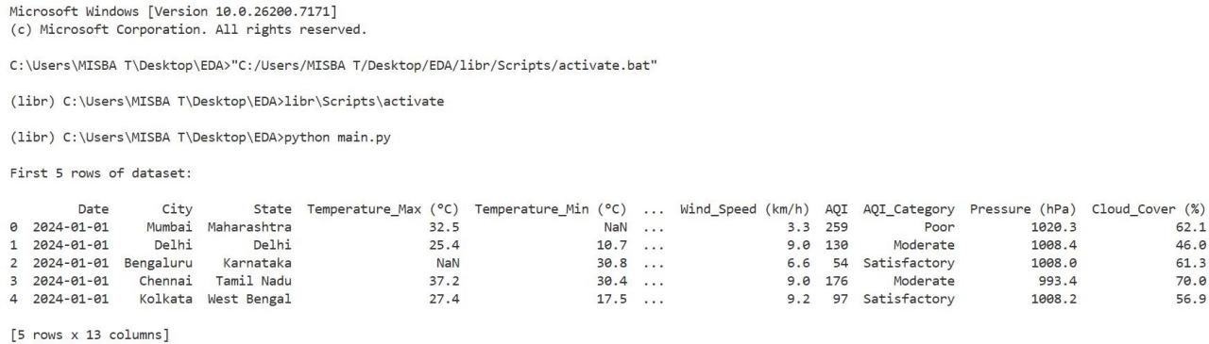

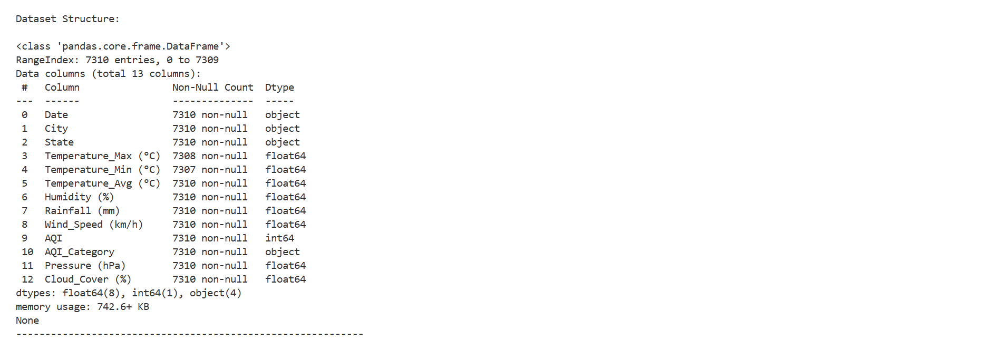

3. Handling Missing Values and Outliers
File Name:handling_missing_value.py
  - Detection of Missing Values
The dataset was first inspected for missing entries using isnull().sum() and notnull().sum(). It was found that Temperature_Max (°C) had 2 missing values and Temperature_Min (°C) had 3 missing values. All other columns, including humidity, rainfall, and AQI, were complete. This step was crucial to identify gaps that could affect the quality of analysis.
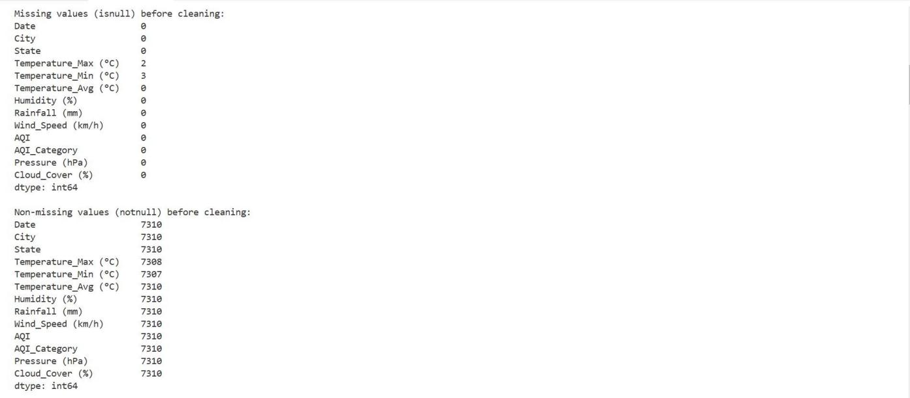

Mean Imputation
To handle the missing numeric values, the mean of each respective column was used for imputation. This approach ensures that the dataset size remains unchanged while maintaining realistic distributions for temperature values. After this step, all numeric columns had zero missing values, making the dataset ready for further processing.
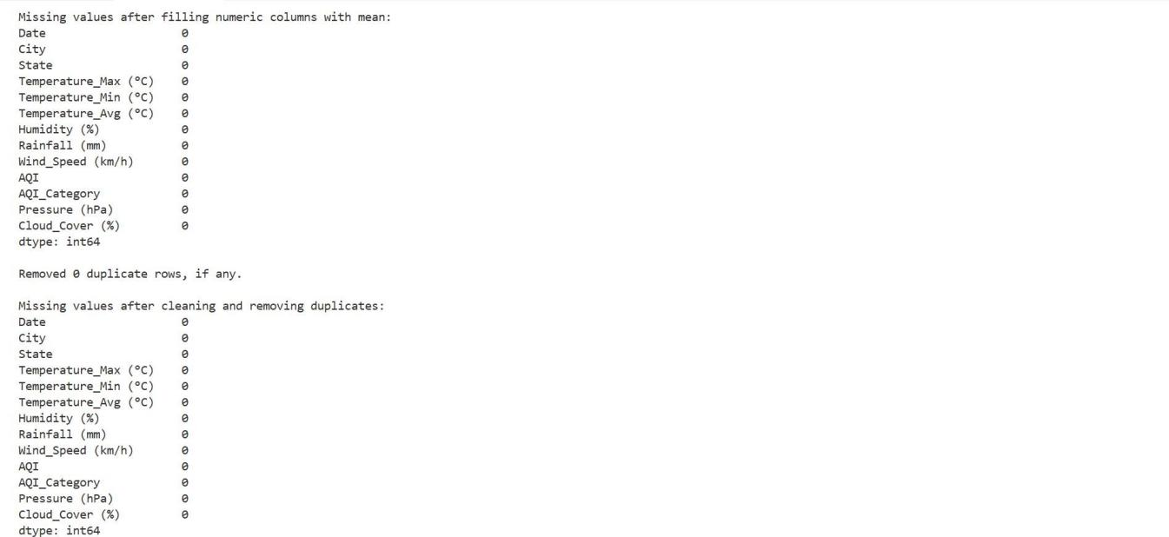

Duplicate Removal
The dataset was checked for duplicate rows using drop_duplicates(). No duplicates were found, confirming that each observation represented a unique record of city-wise climate data. This step ensured the integrity and reliability of the dataset.

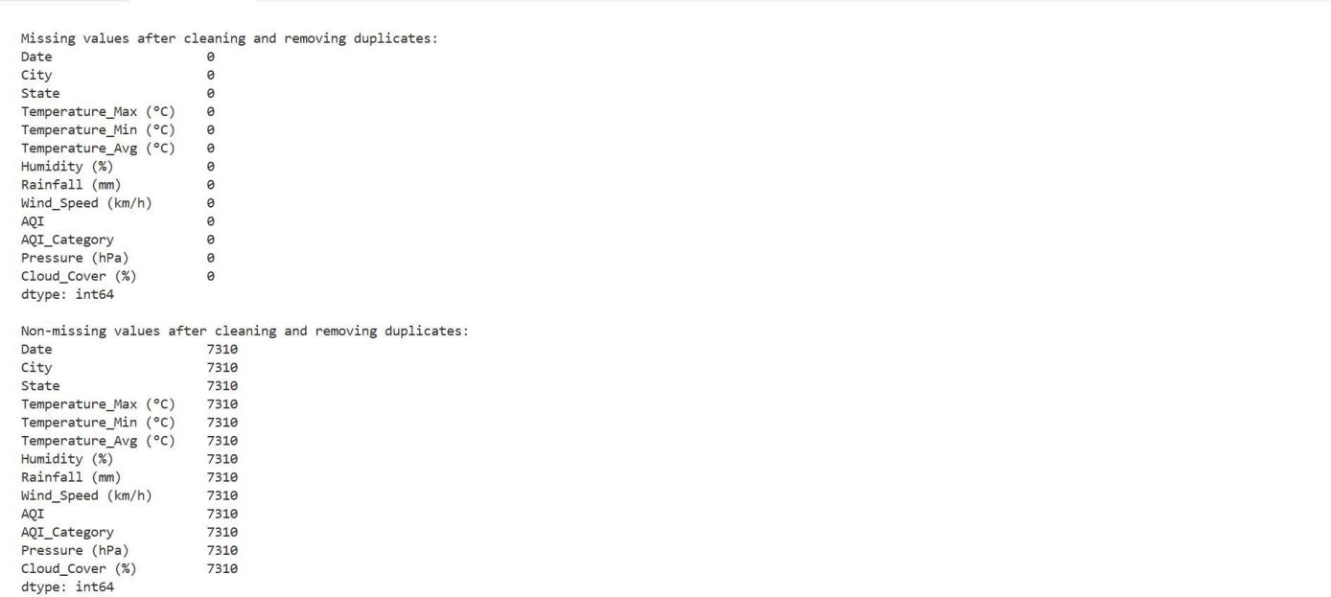

Final Dataset
After handling missing values, duplicates, and outliers, the dataset size was reduced from 7310 to 6270 records. The cleaned dataset, free from missing entries and extreme distortions, was saved as cleaned_dataset.csv. This dataset is now fully prepared for visualization, clustering, and predictive modeling tasks.

4.Explore Data Characteristics

File Name:descriptive_stats.py
The statistical characteristics of the cleaned Indian Climate dataset to understand the typical range and variability of weather across cities.
Using descriptive statistics, we calculated the following for all numeric features.

    - Mean – Average value of the dataset

    - Median – Middle value when data is arranged in order

    - Mode – Most frequently occurring value

    - Standard Deviation – Measure of how spread out the values are

    - Minimum – Smallest value in the dataset

    - Maximum – Largest value in the dataset

The Temperature_Max, Temperature_Min, and Temperature_Avg columns showed mean values of 35.01°C, 25.08°C, and 30.05°C respectively, with moderate variability, reflecting typical daily temperatures in India. Humidity (%) averaged 62.69% with a standard deviation of 18.67%, indicating variation between humid coastal regions and drier inland areas. Rainfall (mm) had a mean of 1.71 but a median of 0, showing that heavy rain events are infrequent. Wind_Speed (km/h) averaged 13.54 km/h, while AQI had a mean of 193.97, highlighting pollution levels across cities. Pressure (hPa) and Cloud_Cover (%) showed moderate variability, with means of 1007.36 hPa and 52.66%, respectively. Overall, these descriptive statistics provide a clear picture of climate distributions, identify typical ranges, and highlight the spread or volatility in temperature, humidity, rainfall, wind speed, AQI, pressure, and cloud cover, laying the foundation for further visualization and analysis.

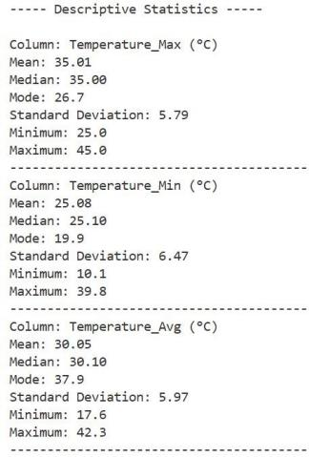

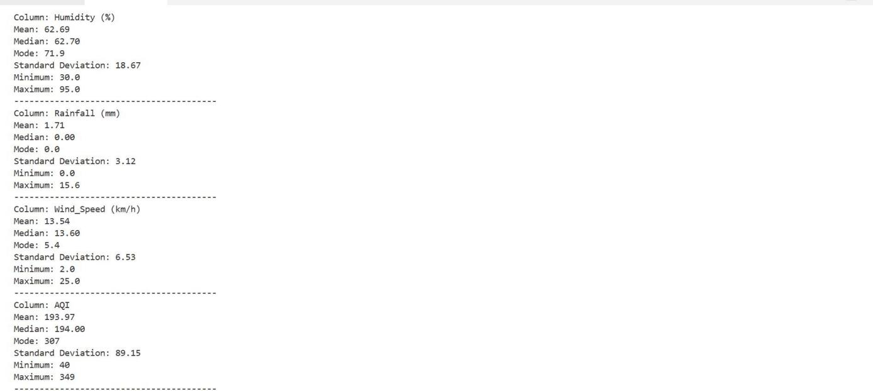
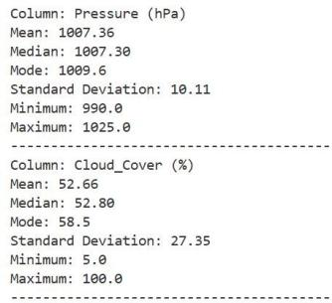

Perform Data Transformation

File Name:data_transformation.py
Transform numeric features to a common scale for accurate analysis and distance-based modeling like K-Means.

  - Min-Max Normalization: Min-Max Normalization rescales all numeric features into the range 0 to 1 using MinMaxScaler, preserving the original distribution while bringing all attributes to a common scale.

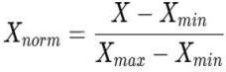

  - Z-Score Standardization: Z-Score Standardization transforms numeric features to have a mean of 0 and standard deviation of 1 using StandardScaler, making the data suitable for clustering and machine-learning algorithms.
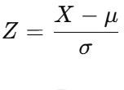

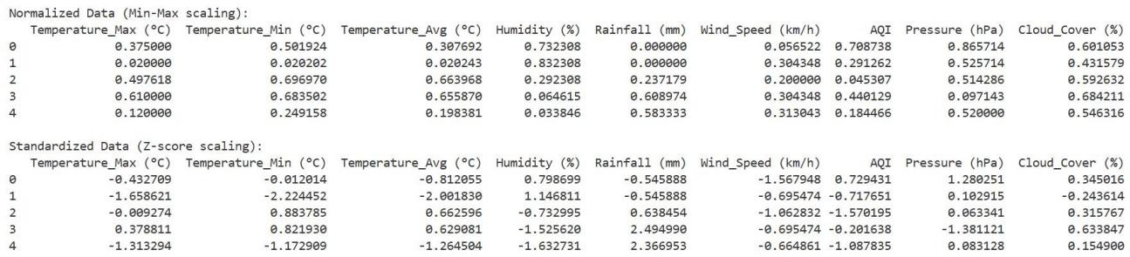

Visualize Data Relationships

File Name:basic_visualizations.py ,advanced_visualizations.py
The purpose of visualization is to transform numerical climate data into graphical formats so that trends, variations, and relationships between weather conditions and AQI can be easily interpreted.

Univariate Analysis:
This analysis focuses on one variable at a time to understand its distribution and individual behavior.

Charts:
    - Histogram – to show the frequency distribution of AQI and temperature values.

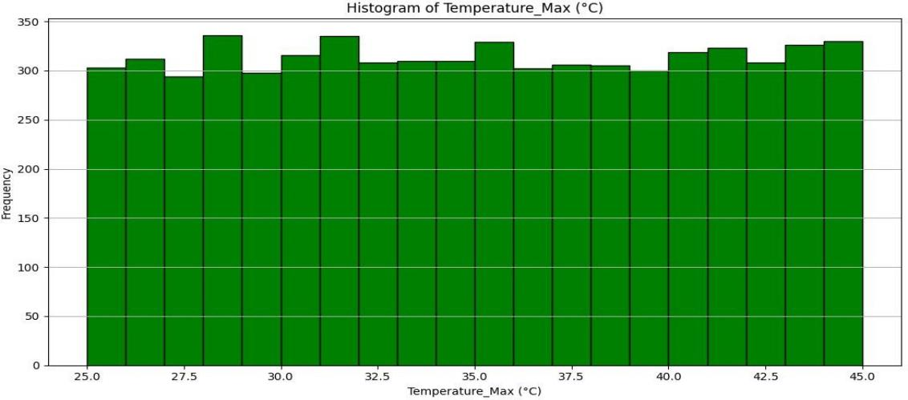

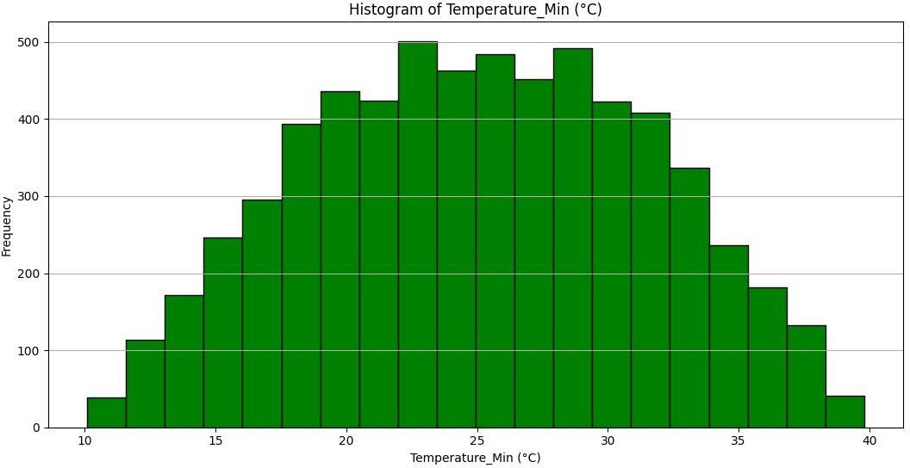

    - Line Plot – to observe trends of individual climate variables over records.

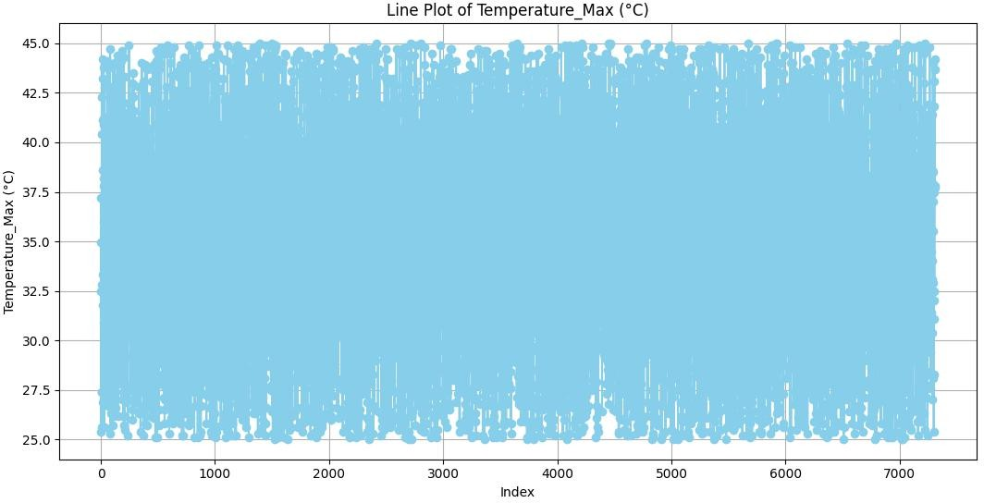

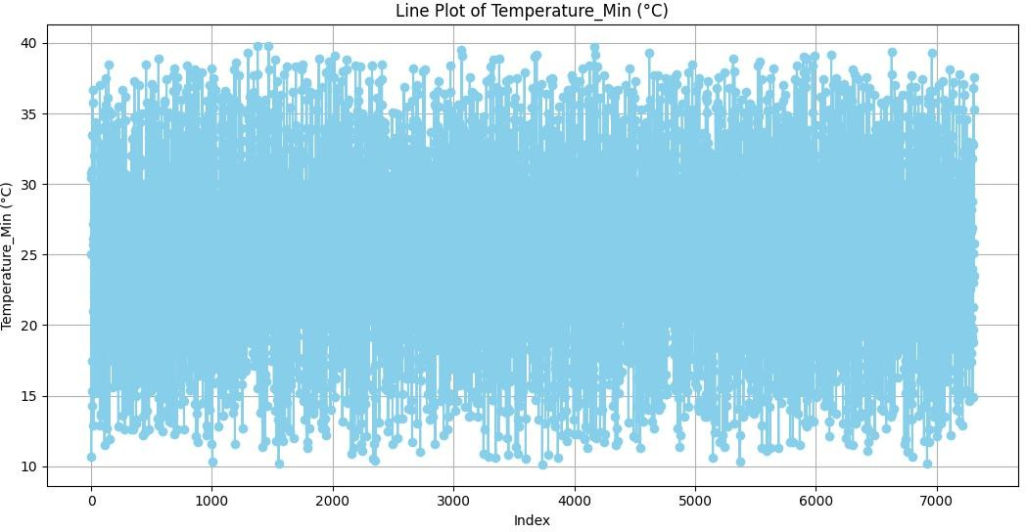

    - Bar Chart – to compare values of the first few observations for each numeric feature
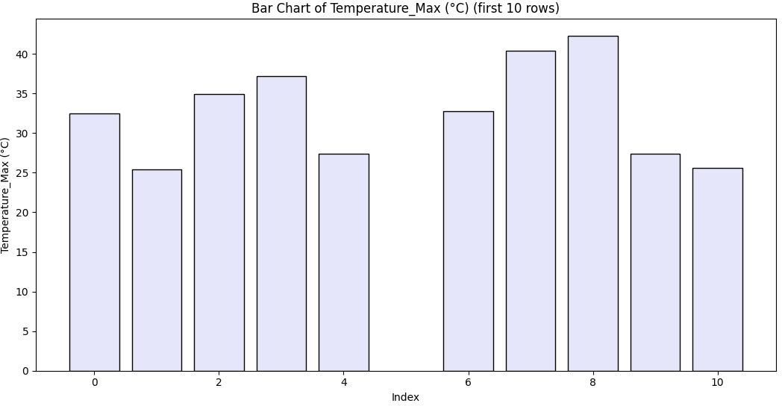

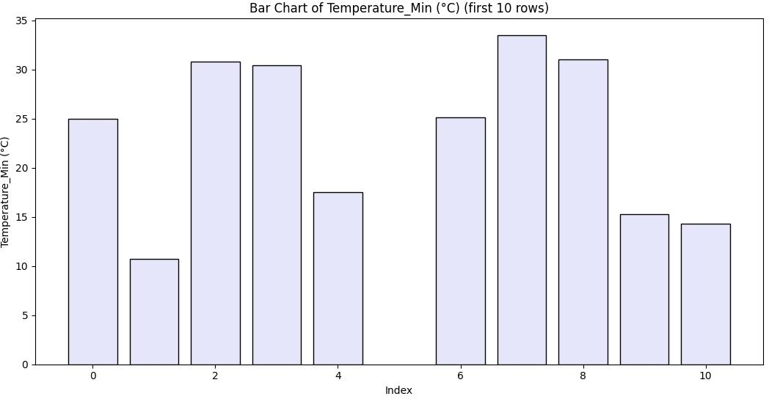

Multivariate Analysis:
This analysis evaluates interactions between multiple climate variables together.

Charts:

    - Pair Plot – to visualize relationships among all numeric features.

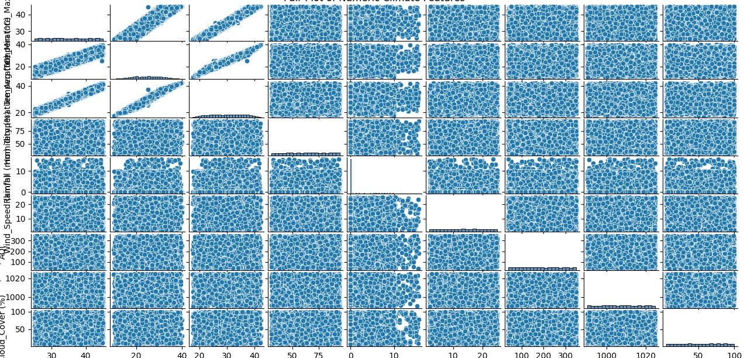

    - Correlation Heatmap – shows the strength and direction of relationships between variables.

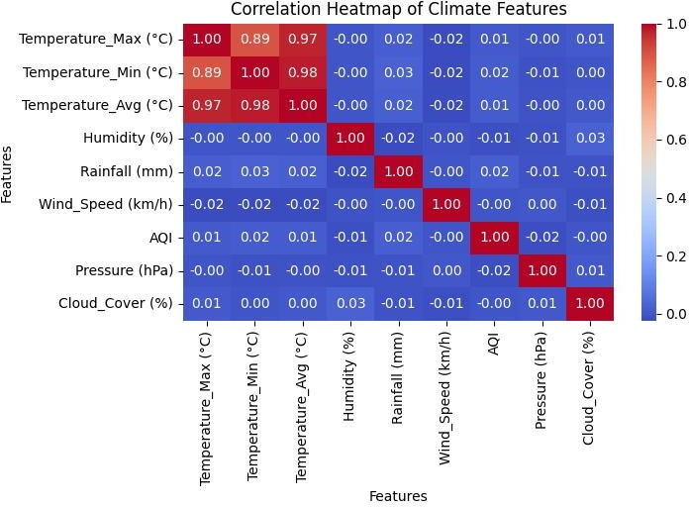

    - Covariance Heatmap – measures how features such as Wind Speed, Cloud Cover, and AQI vary together.

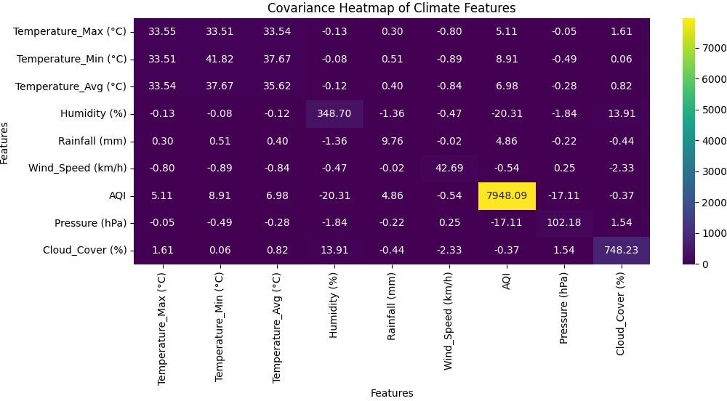

Handling Outliers

File Name:handling_missing_value.py
Outliers in numeric columns were identified using the Interquartile Range (IQR) method. While most features had no extreme values, Rainfall (mm) contained 1040 outliers representing unusually heavy rainfall days. These extreme values were removed to prevent skewed analysis and maintain statistical consistency.

Logic:

Calculate Q1(25th percentile) and Q3(75th percentile).

Define bounds: Lower = Q1 - 1.5 *IQR; Upper = Q3 + 1.5*IQR

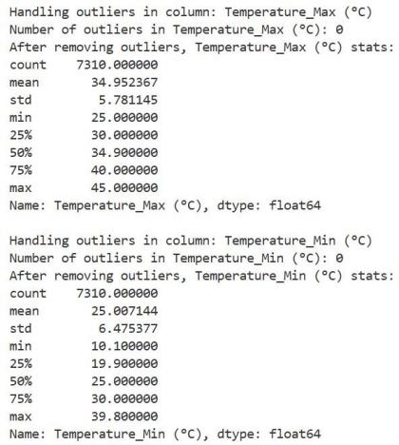

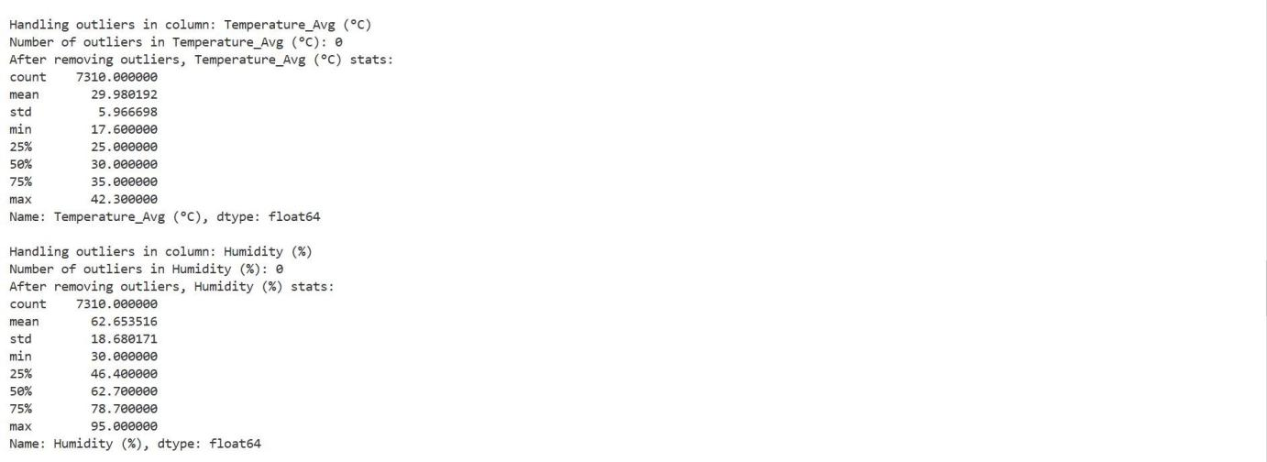
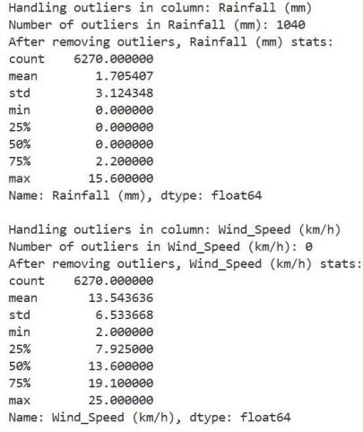
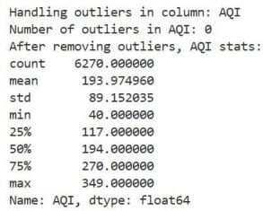

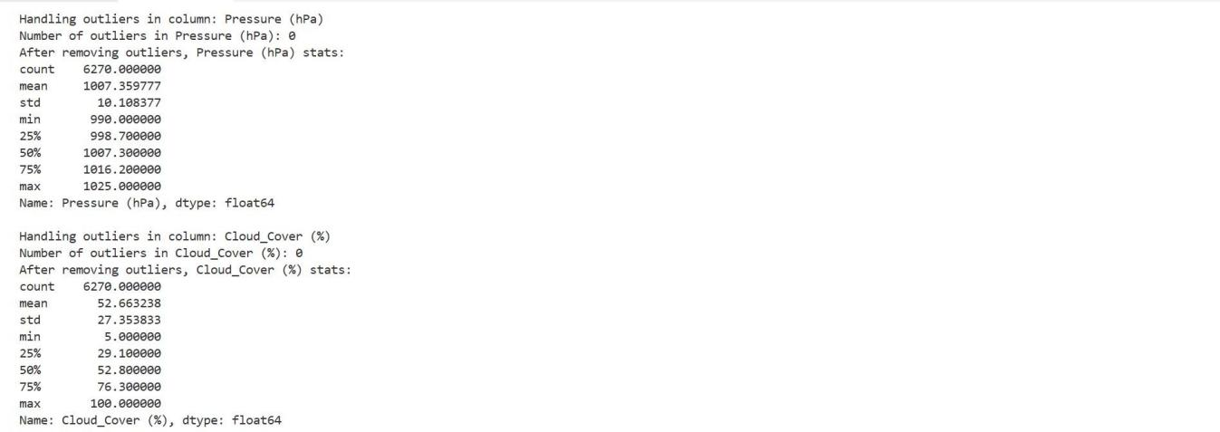

8.Communicate Findings and Insights

File Name:dashboard.py,
The purpose of this step is to present the analyzed Indian Climate dataset in an interactive and meaningful way so that users can easily understand climate trends, air quality variations, and regional patterns.

Interactive Dashboard:
A Dash-based web dashboard was developed to display climate trends dynamically, making the analysis accessible to non-technical users.

City Dropdown:
A dropdown menu allows users to select a specific city, enabling real-time filtering of climate records.

Trend Analysis:
Interactive line graphs display the progression of major numeric climate parameters such as Temperature, Rainfall, and AQI over time for the selected city.
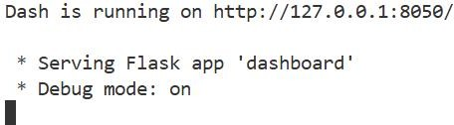
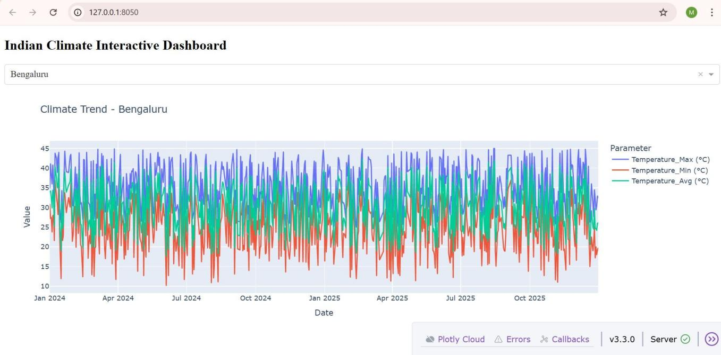

Probability Analysis:

File Name:probability_analysis.py
Range and variance were calculated for key numeric variables to understand their spread and variability, and histograms with KDE curves were plotted to observe probability distributions.
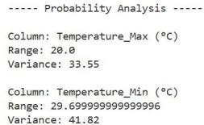

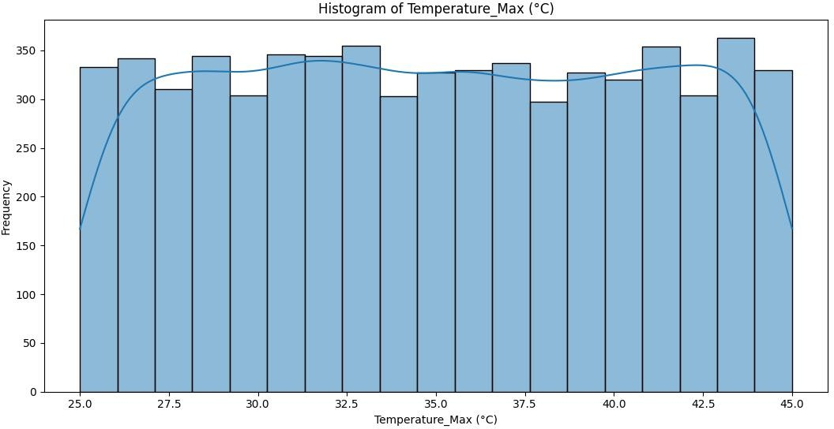

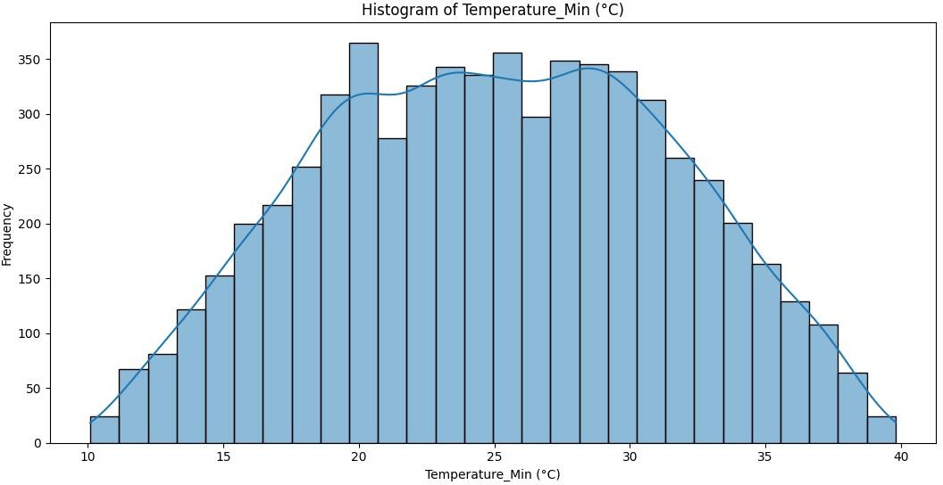

K-Means Clustering:

File Name:kmeans_modeling.py
The standardized numeric dataset was clustered into three segments using the K-Means algorithm.

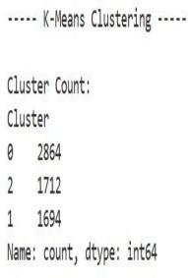

Cluster Visualization:
A scatter plot and pair plot were generated to visually distinguish clusters and observe inter- feature relationships.

Scatter plot - Bivariate Analysis:
This analysis examines the relationship between two variables simultaneously.

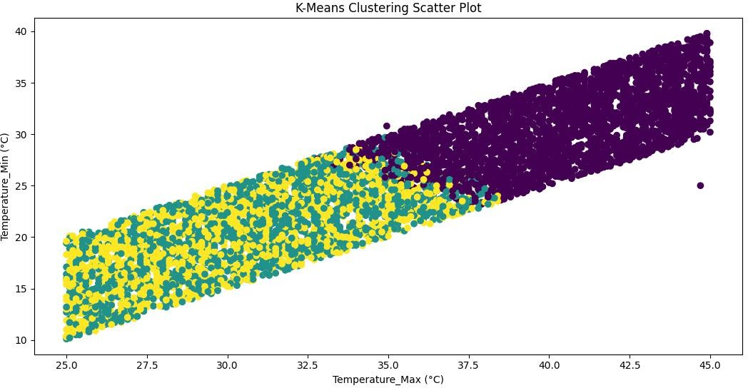

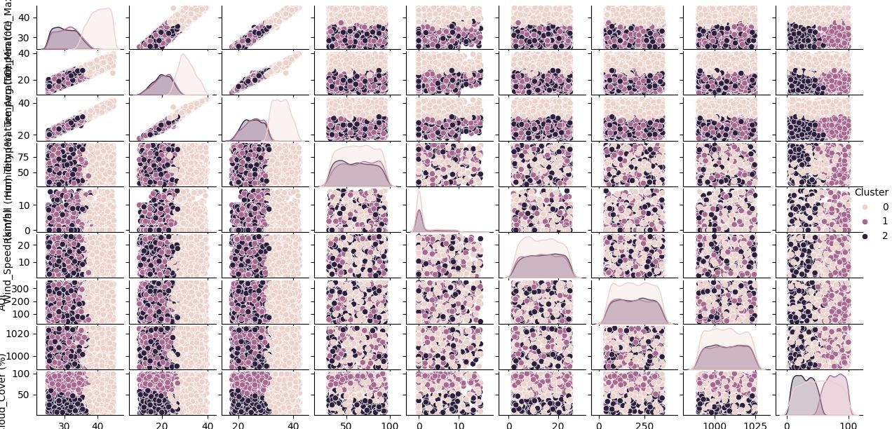

Kmeans-Pairplot

Interpretation:
Cluster-wise means were computed to interpret environmental behavior across different climate zones.

CONCLUSION:
This project successfully performed an end-to-end Exploratory Data Analysis on the Indian Climate dataset. The raw data was cleaned by handling missing values, removing outliers, and eliminating inconsistencies. Descriptive statistics and visualizations revealed important patterns in temperature, rainfall, humidity, and AQI across Indian cities. Data transformation techniques ensured fair comparison among features for accurate modeling. Interactive dashboards enabled real-time exploration of city-wise climate trends. K-Means clustering identified distinct climate zones with unique environmental behaviors. Overall, the study provides meaningful insights that can support environmental monitoring and data-driven decision making.

